1. Indique el nombre correspondiente a cada elemento de la ventana de Microsoft Excel.

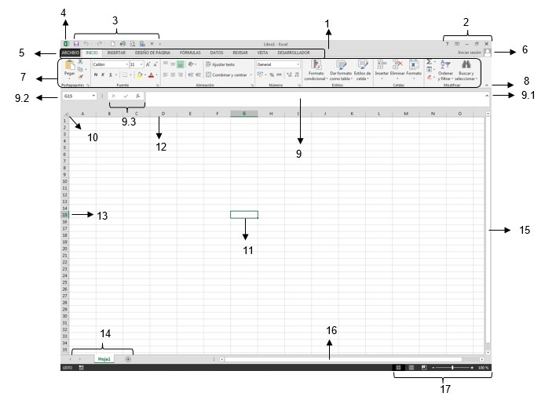

1. _________________________________ 2. _________________________________

3. _________________________________ 4. _________________________________

5. _________________________________ 6. _________________________________

7. _________________________________ 8. _________________________________

9. _________________________________ 9.1 _________________________________

9.2 _________________________________ 9.3 _________________________________

10. _________________________________ 11. _________________________________

12. _________________________________ 13. _________________________________

14. _________________________________ 15. _________________________________

16. _________________________________ 17. _________________________________

1. Escriba a que **Ficha** y **Grupo de Iconos** pertenecen los siguientes conjuntos de iconos:

|  |  |  |  |  |  |  |  |
| --- | --- | --- | --- | --- | --- | --- | --- |
|  |  |  |  | |  |  | |
| Ficha: ______________________ Grupo de Iconos: _________________ | Ficha: ____________________ Grupo de Iconos: _________________ |
|  |  |  |  | |  |  | |
| Ficha: ____________________ Grupo de Iconos: _________________ | Ficha: ____________________  Grupo de Iconos: _________________ |
|  |  |  |  |  | | |  |
| Ficha: ____________________ Grupo de Iconos: _________________ |
| Ficha: ____________________ Grupo de Iconos: _________________ | | |

1. Defina que es EXCEL: ____________________________________________________________________________________________________________________________________________________________________________________________________________________________________________________________________________________________________________________________________________________________

1. Indique la diferencia que encuentra entre:
   1. Hoja de cálculo y Libro de trabajo: _____________________________________________________

* 1. Celda y Rango de celdas: _____________________________________________________________

1. Defina la utilidad de los siguientes elementos de la ventana:
   1. Cuadro de nombres: ________________________________________________________________
   2. Botón Introducir: ___________________________________________________________________
   3. Botón Cancelar: ____________________________________________________________________
   4. Botón Insertar función: ______________________________________________________________
   5. Cabecera de filas: __________________________________________________________________
   6. Cabecera de la hoja: _________________________________________________________________
   7. Área de edición de la celda activa: _____________________________________________________
   8. Cabecera de columnas: ______________________________________________________________
   9. Barra de etiquetas: __________________________________________________________________
   10. Celda activa: _______________________________________________________________________